Denis Tenev
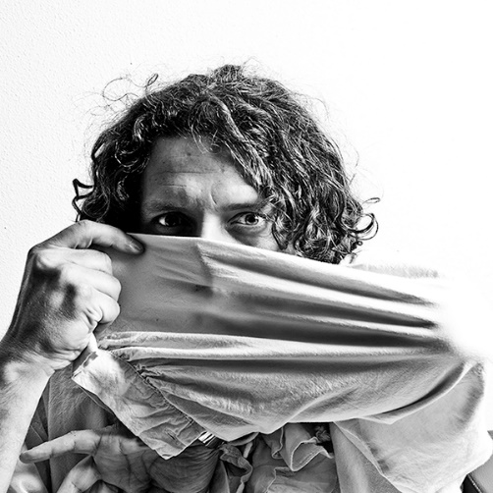
Painter, Multimedia Artist, Graphic Designer
Typographer, Photographer

Born: 05.X.1967 Skopje, R. Macedonia
Live and work in Skopje
Mail:
-Borka Taleski 26-5/55 1000 Skopje, R.Macedonia

Mobile:
+38975260376
E-mail: denis@tenevart.at
Web: www.tenevart.at

Education
Academy of Fine Art; Skopje, Macedonia
Graduated in 1994 with degrees in painting and graphic design
New Bulgarian University, Sofia, Bulgaria
Graduated in 2006 with MA in Ancient Archaeology
Academy of Fine Art; Skopje, Macedonia
In September 2009 starting MA program in painting Department
2014-Oficial Adobe Certificate for Adobe Photoshop CS6 – (xVCu-s23V)

Work Experience
November 2013- present
Professor for Digital Art and Animation on Multimedia department at State High School for Art - DSULUD-Lazar Licenoski, Skopje, Macedonia

July 2018-2019
Work as live artist at Café Hawelka, Vienna, Austria

July 2017-present
Founder and artist on an interactive project: Wien und Ich, Vienna, Austria

November 2013-2017
Founder and Professor for Digital Art and Animation on Multimedia department at State High School for Art - DSULUD-Lazar Licenoski, Skopje, Macedonia

October 2006 – 2014
Founder and Graphic design instructor for Typography, Theory of Color,
Advanced Photoshop CS5
SEMOS Education (College for Graphic and Web Design) Skopje, Macedonia
2002 – 2014
Freelance artist (Official State Status in R. Macedonia)
2006 – 2014
member of the expert team of Prof. Dragi Mitrevski for archaeological excavations of ancient Fortress KALE-Skopje
2002 – 2013
member of many archaeological excavations for drawing and digital processing of archaeological findings

Outsource Art editor in Magazines:
2009/2010
Global HR (Magazine for Human Resources)
2006
Music & Sound Magazine
2005/2006
MK Shopping Magazine
2004
Business Press Magazine
2003
PhotonArt Magazine
2001 / 2002
Semeen Magazin (Family Magazine)
2000 / 2002
PULS Magazine, Conception and Production of cover artwork
1999 / 2001
ZENA (WOMAN Magazine)
1997 / 1998
Graphic designer, FONKO Prepress Studio
1995 / 1996
Graphic designer, Akzent Media

Art Exhibitions
July 2019
Independent exhibition: “Survival” drawings and paintings “made in café Hawelka - Vienna” in the period 2018/2019.
ART GALLERY Kunstraum Wien Mitte - Vienna, Austria
August 2016
Permanent stand: painting with historical mass scenes “Resen Counseling”
800cm x 400cm at MUSEUM – HOUSE OF TATARCHEVI - Resen, Macedonia
May 2014
Independent exhibition: “Digital VS Classical”
ART GALLERY and MUSEUM - Veles, Macedonia
September 2013
Permanent stand: digitally prepared bas relief scene from archeological finding “Adulthood of Alexander the Macedon” 400cm x 200cm at MACEDONIAN NATIONAL THEATRE - Skopje, Macedonia
March 2012
Independent exhibition: “Esoteric line”
CINEMATEQUE OF MACEDONIA - Skopje, Macedonia
May 2011
Independent exhibition: “Typographic Mosaics”
KIC - Skopje, Macedonia
December 2010
Group exhibition: “Saint Kliment and Naum ”
MUSEUM OF CITY of Skopje, Macedonia
September 2010
Group exhibition: “Chianciano International Award”
Chianciano, Italy
September 2009
Group exhibition: “ArtLine Ebersberg”
Ebersberg, Germany
February 2009
Independent exhibition: “digiDRAW”
Gallery Art`est, Paris, France
September 2008
Group exhibition: “Say Macedonia”
“Prima Center Berlin”; Berlin, Germany
June 2007
Independent exhibition – digital art: “Art Megabyte”
MC Gallery; New York, USA
May 2007
Independent exhibition: “Spiritual Macedonia”
Spiritual Center; Zrenjanin, Serbia
April 2007
Independent exhibition – photography: “Me and Israel”
National Gallery of Macedonia; Skopje, Macedonia
February 2006
Independent exhibition: “Spiritual Macedonia”
National Museum and Gallery; Strumica, Macedonia
February 2006
Group exhibition: “Sun for All”
Colony Wedding; Berlin, Germany
March 2005
Independent exhibition: “Art Megabyte”
Prima Center; Berlin, Germany
March 2004
Independent exhibition: “Body Language”
Cultural Info Center; Skopje, Macedonia
March 2004
Independent exhibition: “Macedonian Art”
Oberbank; Vienna, Austria
November 2001
Independent exhibition: “The Man”
DLUM Gallery; Skopje, Macedonia
March 1999
Independent exhibition: “Dialogue”
Macedonian Army Cultural Center; Skopje, Macedonia
From 1998 to present
Many group exhibitions with DLUM
(The Painters Association of Macedonia)

Art Colony
July 2012
International Art Colony
Ohrid, Macedonia
September 2011
International Art Colony
Durras, Albania
August 2011
International Art Colony Arka
Skopje, Macedonia
June 2011
International Aquarelle Colony
Ohrid, Macedonia
April 2011
International Art Colony
Ohrid, Macedonia
August 2010
International Aquarelle Colony
Skopje, Macedonia
August 2010
International Art Colony & Group exhibition
Zlarin, Croatia
May 2010
International Art Colony & Group exhibition
Pogradec, Albania
May 2010
International Art Colony
Ohrid, Macedonia
September 2008
Graphic Colony & Group exhibition
Bogdanci, Macedonia
August 2008
International Art Colony & Group exhibition: “AQUARELA SANTA CRUZ”
Santa Cruz, Portugal
April 2007
International Colony, Reshetari; Croatia

Associations
October 2000 /01
Participated in the educational project “Practicum” in cooperation with the Museum of Contemporary Art, Skopje, Macedonia
1998 – present
Member of DLUM (The Painters Association of Macedonia)
Awards
2010 – Dlum award “Golden Brush” for miniature
2010 - “Chianciano International Award” Art Museum Chianciano, Italy - award of honor for Digital Art
2009 - SEMOS – award for best instructor in College for Graphic Design
2003 - NUB award for graphic arts
2000 - PULS magazine award

